State and Permission Matrix
Two questions on one page: who may do what (role and department), and what may be done in each status (the locks). Both are checked by the backend on every call; the frontend only hides what a user may not use.

1. Roles
Role | Department | Meaning
Admin | any (only a label) | does everything
Worker | Sales | Sale Worker: quotations (a production order is read only)
Worker | Factory | Factory Worker: the processes, production, stock, purchase

A Worker must have the department Sales or Factory; the department decides the access. The role check comes before the check that the record exists: a user who may not touch a record gets 403, never 404.

2. Who may do what
Area | Action | Admin | Sale Worker | Factory Worker
Dashboard | order tiles | yes | yes | yes
Dashboard | invoice tiles and chart | yes | no | no
QT | see, create, change, print | yes | yes | no
QT | upload customer PO, Confirm, delete a Draft | yes | yes | no
Production order | read | yes | yes | yes
Production order | add or change the processes before the start | yes | no | yes
Production order | Start production (deducts stock) | yes | no | yes
Production order | Record progress | yes | no | yes
Production order | change or reopen a Completed process | yes | no | no
Production order | evidence files: read | yes | yes | yes
Production order | evidence files: upload, delete | yes | no | yes
Stock | read materials, lots, movements | yes | yes | yes
Stock | Add / Deduct / Adjust a lot | yes | no | yes
Materials | create, change, delete | yes | no | no
Purchase | PO: create, change, print, move status, pay, files | yes | no | yes
Suppliers | read | yes | no | yes
Suppliers | create, change, delete | yes | no | no
Customers | read | yes | yes | no
Customers | create, change, delete | yes | no | no
Products | read | yes | yes | yes
Products | create, change, delete | yes | no | no
Accounting | invoices, payments, receipts | yes | no | no
Users | read, create, change, delete | yes | no | no

Menus follow the same table: an entry shows only for the roles and departments that may use it.

3. Statuses and what each allows

QT
Status | Customer and lines | Other fields | Delete | Confirm | Next
Draft | change | change | yes | yes (once) | Confirmed
Confirmed | locked (409 QT_LOCKED) | change | no (409 IN_USE) | already done: shows the existing order | –

Confirm needs a customer and at least one line. A missing customer PO file is only a warning. Confirm makes one Draft production order and copies the PO file to it.

Production order (status is computed from its processes)
Status | Edit lines and processes | Start | Record progress | Next
Draft, not started | yes (Admin, Factory Worker) | needs a line, a process on every line and enough stock (409 ORDER_NOT_READY, 409 STOCK_SHORT) | no (409 ORDER_NOT_STARTED) | In progress
In progress | no (locked by the start) | already started | yes | Completed
Completed | no | – | no, except an Admin reopening a process (note required) | invoiced
Invoiced | no | – | no (409 ORDER_INVOICED) | –

Process
Status | Quantity | Who may change
Not started | 0 | Admin, Factory Worker
In progress | partial | Admin, Factory Worker
Completed | the full quantity | Admin only; reopening needs a note (403 COMPLETED_LOCKED for a Worker)

Purchase order
Status | Change lines | Delete | Files | Payment | Next (by hand, one step only)
Draft | yes | yes | yes | no | Sent
Sent | no (409 PO_LOCKED) | no | yes | no | Received
Received | no | no | yes | once (409 ALREADY_PAID) | –

Received adds the stock once, into the lot typed for each line; a second Received changes nothing (409 INVALID_STATUS_CHANGE). Payment before Received answers 409 PO_NOT_RECEIVED. The amount must equal the total.

Invoice
Status | Payment | Result
Unpaid | one full payment (amount = total) | Paid
Paid | no (409 ALREADY_PAID) | receipt issued, once

An invoice is made only for a Completed order (409 ORDER_NOT_COMPLETED), one per order (409 INVOICE_EXISTS), as a snapshot. It locks the progress of the order.

Supplier (the only record with an Active switch)
Active | New or changed PO | Existing POs
yes | can be chosen | unchanged
no | cannot be chosen | stay as they are

4. One job through the statuses
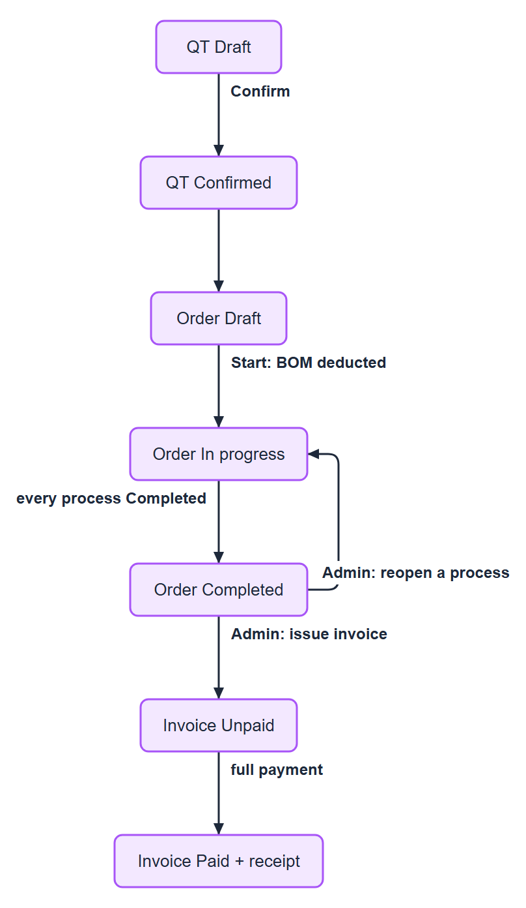
Figure 1. 4. One job (QT, order, invoice) and one purchase order through the statuses
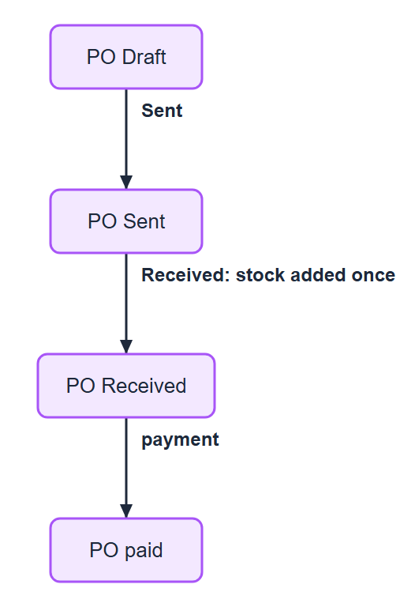
Figure 2. 4. One job (QT, order, invoice) and one purchase order through the statuses

5. Locks at a glance
Lock | Starts when | What it blocks | Error
QT locked | Confirm | change of customer and lines, delete | QT_LOCKED, IN_USE
Order locked | Start production | change of lines and processes | ORDER_LOCKED
Completed process | process Completed | change by a Worker | COMPLETED_LOCKED
Order invoiced | invoice issued | progress updates | ORDER_INVOICED
PO locked | status leaves Draft | change and delete of the PO | PO_LOCKED
PO file copy | Confirm QT | delete of the PO file copy on the order | FILE_LOCKED
In use | another record uses it | delete of customers, products, materials, suppliers | IN_USE

